Test Case: tc005_SPX_Dev5_Crear_Requisicion_Spot_Con_FAD_Tipo_Cobro_Project
Step 1 - Enter username and password and click to button Enter: Credentials Entered
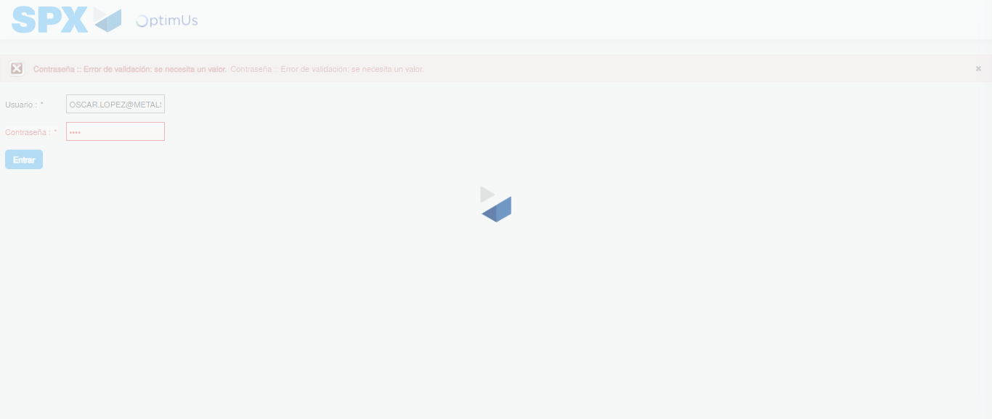Image file-name: QC_Testing-tc005_SPX_Dev5_Crear_Requisicion_Spot_Con_FAD_Tipo_Cobro_Project-1784653597429

Step 2 - Select to UEN and Access to Spot Buy Requisitions : UEN Correctly selected and Correct access
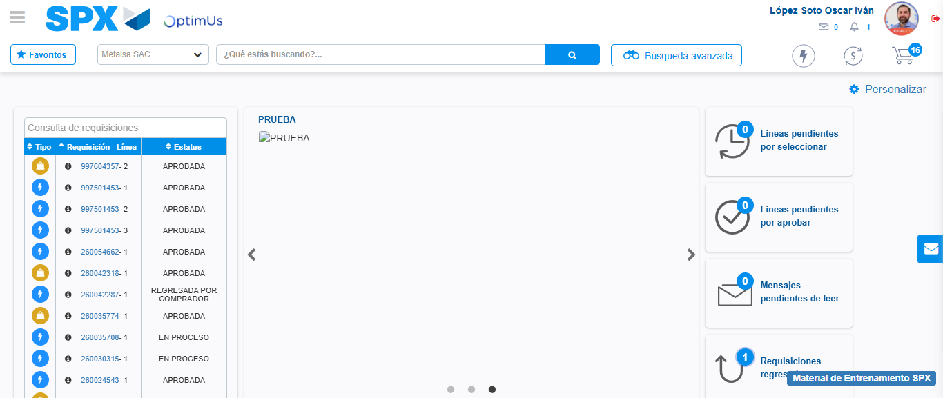Image file-name: QC_Testing-tc005_SPX_Dev5_Crear_Requisicion_Spot_Con_FAD_Tipo_Cobro_Project-1784653664358

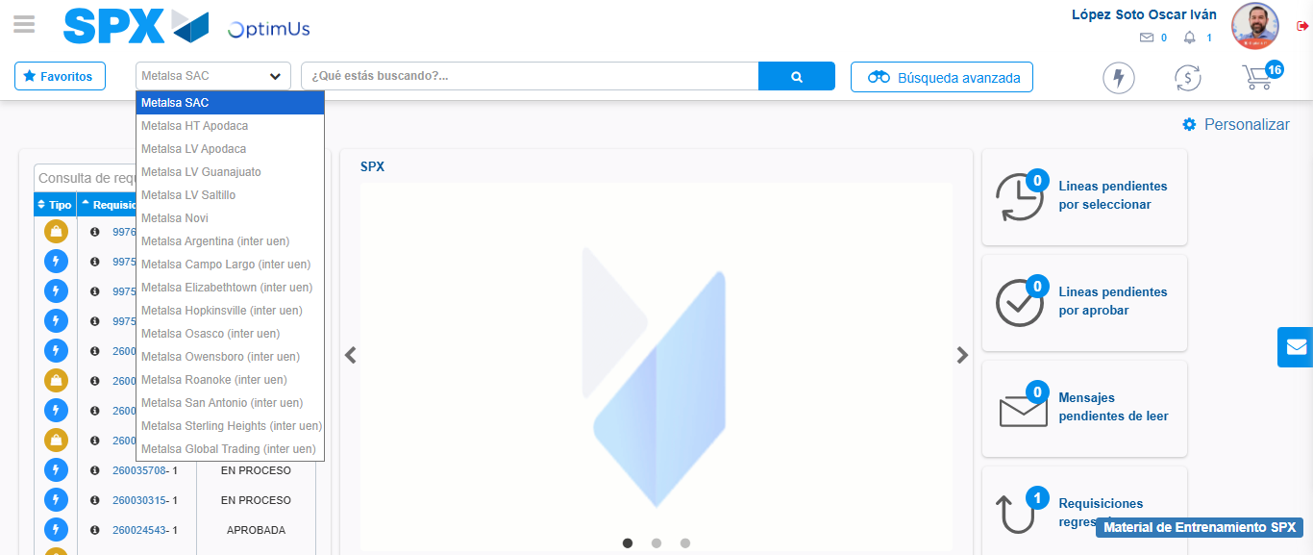Image file-name: QC_Testing-tc005_SPX_Dev5_Crear_Requisicion_Spot_Con_FAD_Tipo_Cobro_Project-1784653667067

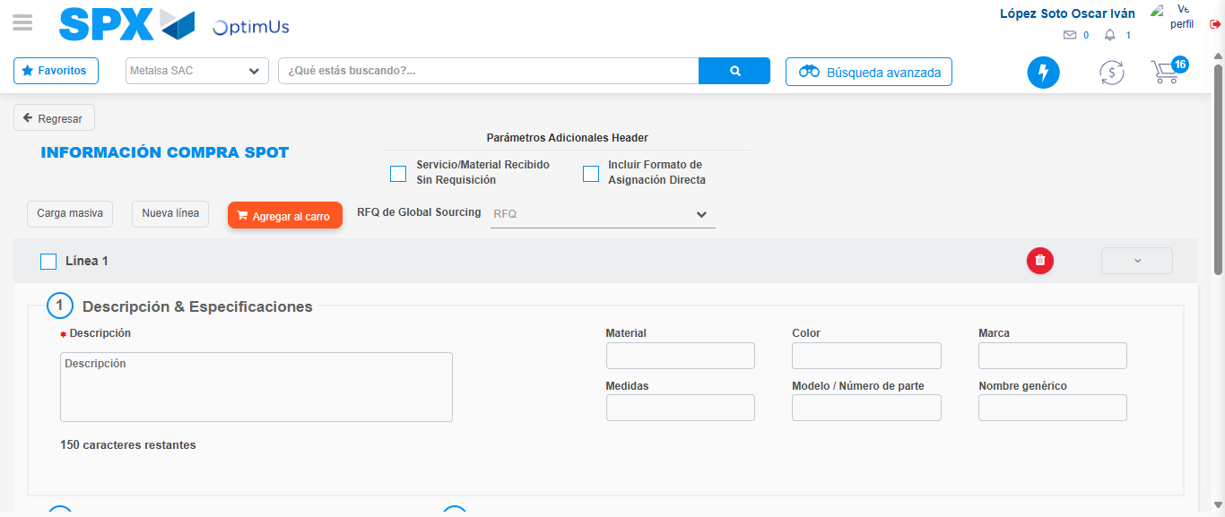Image file-name: QC_Testing-tc005_SPX_Dev5_Crear_Requisicion_Spot_Con_FAD_Tipo_Cobro_Project-1784653676746

Step 3 - Add FAD to Requisition: FAD Successfully Added
Image file-name: QC_Testing-tc005_SPX_Dev5_Crear_Requisicion_Spot_Con_FAD_Tipo_Cobro_Project-1784653677021

Image file-name: QC_Testing-tc005_SPX_Dev5_Crear_Requisicion_Spot_Con_FAD_Tipo_Cobro_Project-1784653677249

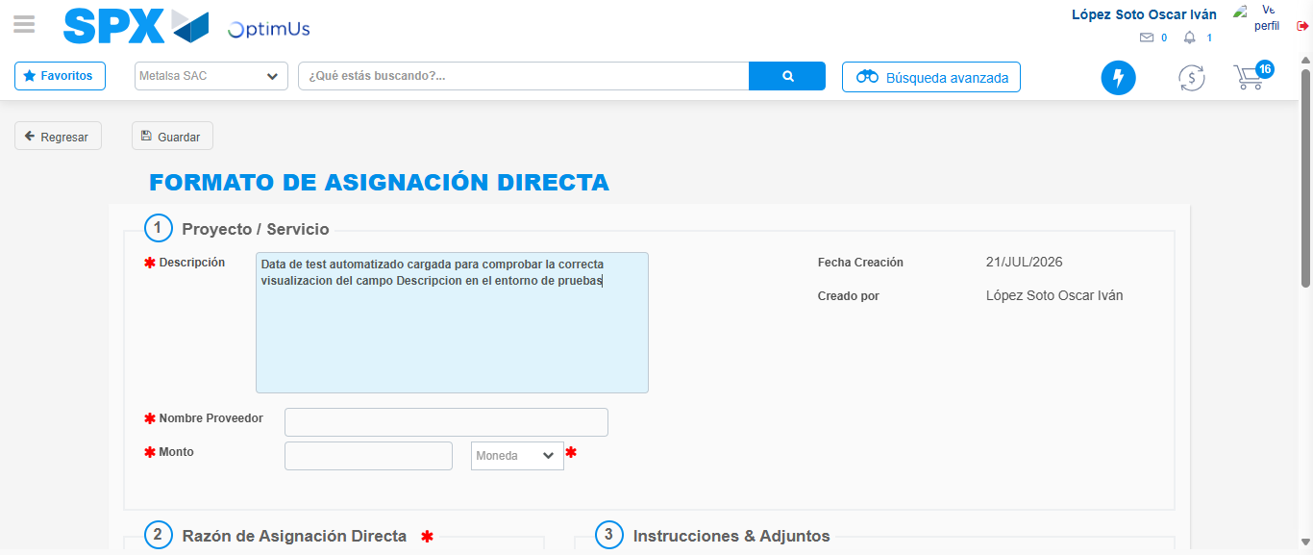Image file-name: QC_Testing-tc005_SPX_Dev5_Crear_Requisicion_Spot_Con_FAD_Tipo_Cobro_Project-1784653680289

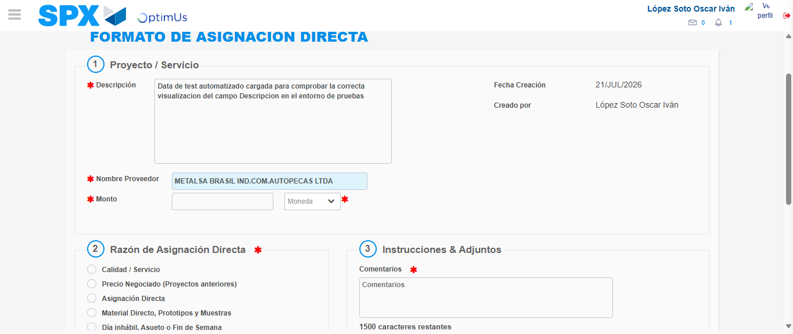Image file-name: QC_Testing-tc005_SPX_Dev5_Crear_Requisicion_Spot_Con_FAD_Tipo_Cobro_Project-1784653687007

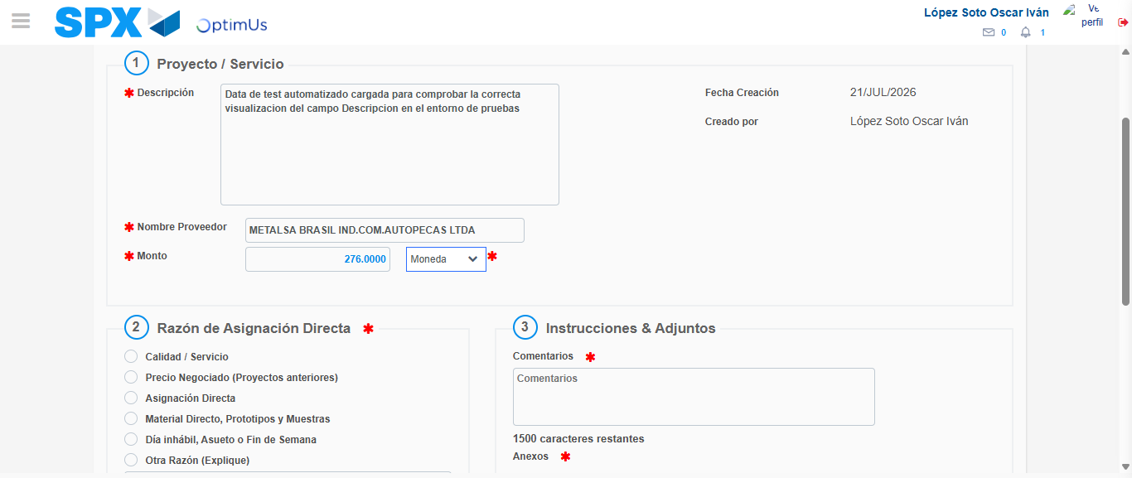Image file-name: QC_Testing-tc005_SPX_Dev5_Crear_Requisicion_Spot_Con_FAD_Tipo_Cobro_Project-1784653687530

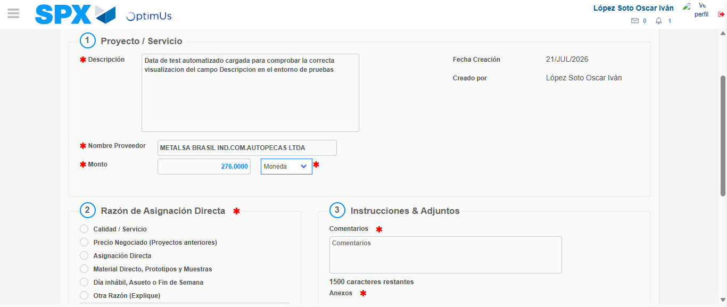Image file-name: QC_Testing-tc005_SPX_Dev5_Crear_Requisicion_Spot_Con_FAD_Tipo_Cobro_Project-1784653687797

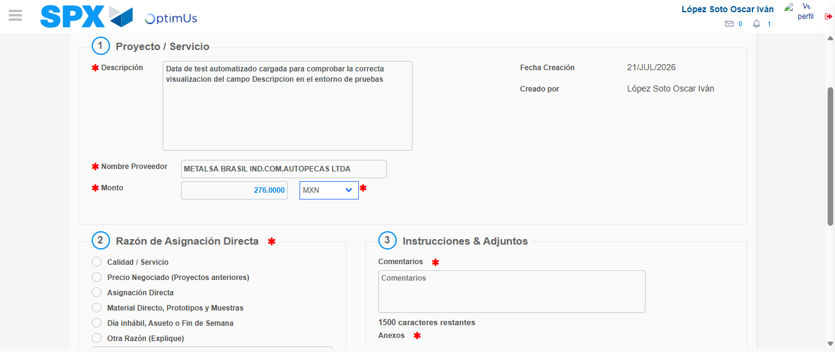Image file-name: QC_Testing-tc005_SPX_Dev5_Crear_Requisicion_Spot_Con_FAD_Tipo_Cobro_Project-1784653688250

Image file-name: QC_Testing-tc005_SPX_Dev5_Crear_Requisicion_Spot_Con_FAD_Tipo_Cobro_Project-1784653688482

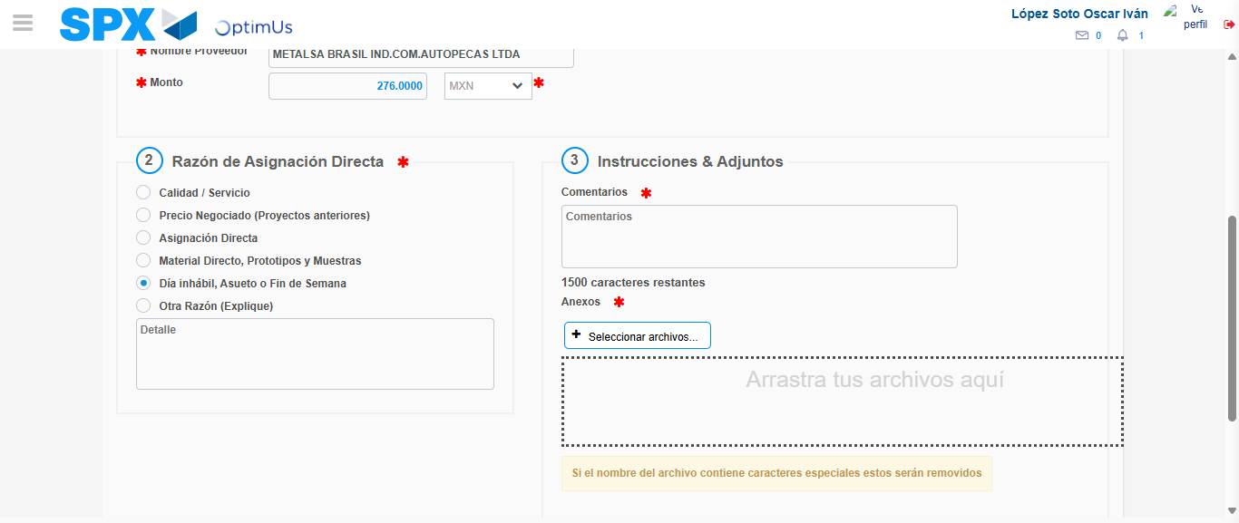Image file-name: QC_Testing-tc005_SPX_Dev5_Crear_Requisicion_Spot_Con_FAD_Tipo_Cobro_Project-1784653689413

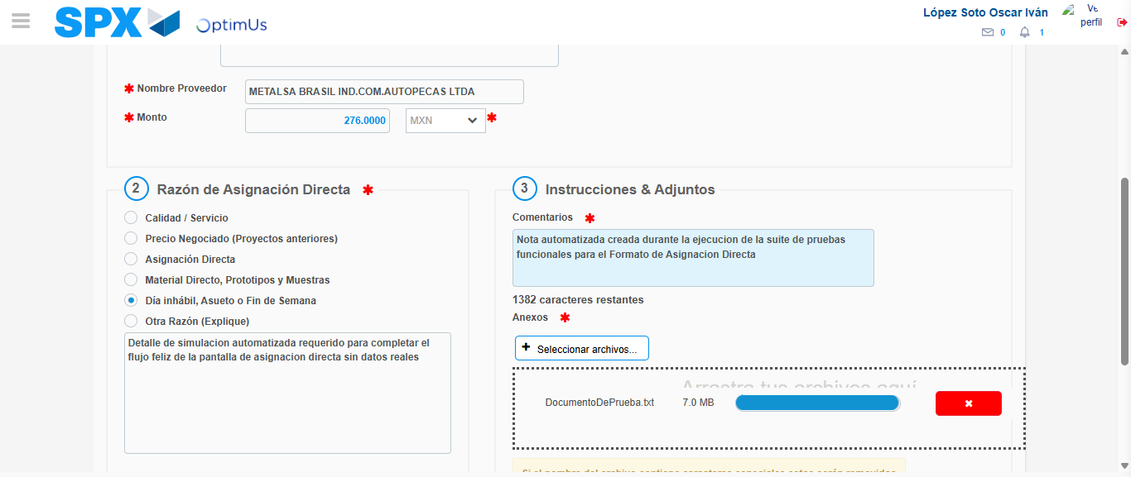Image file-name: QC_Testing-tc005_SPX_Dev5_Crear_Requisicion_Spot_Con_FAD_Tipo_Cobro_Project-1784653700812

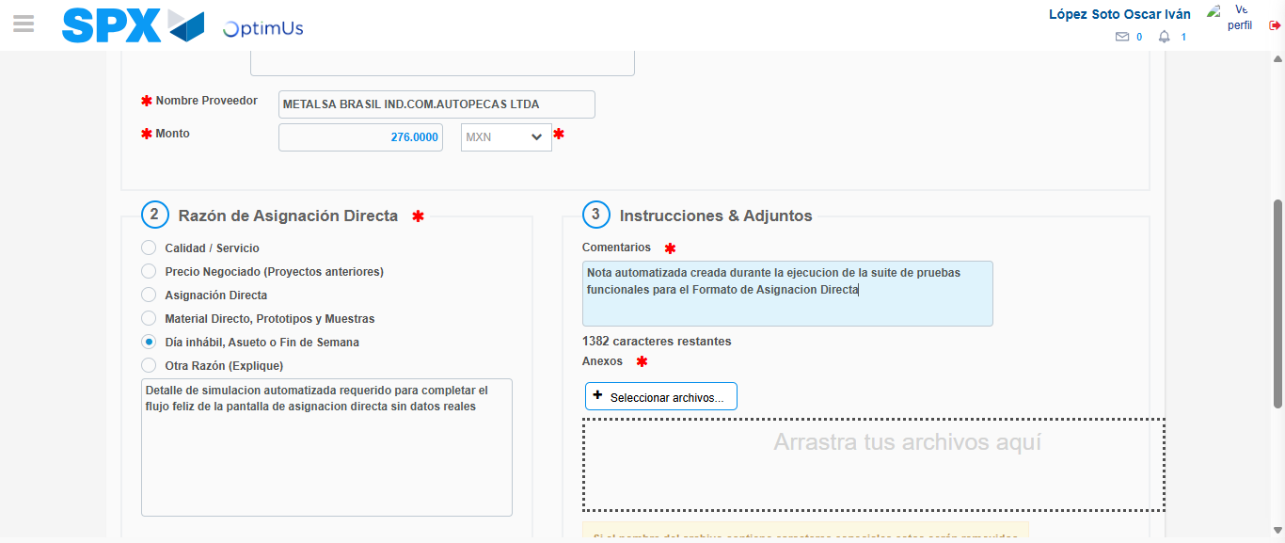Image file-name: QC_Testing-tc005_SPX_Dev5_Crear_Requisicion_Spot_Con_FAD_Tipo_Cobro_Project-1784653702184

Step 4 - Data Capture Spot Buy Requisition: Data captured correctly
Image file-name: QC_Testing-tc005_SPX_Dev5_Crear_Requisicion_Spot_Con_FAD_Tipo_Cobro_Project-1784653677021

Image file-name: QC_Testing-tc005_SPX_Dev5_Crear_Requisicion_Spot_Con_FAD_Tipo_Cobro_Project-1784653677249

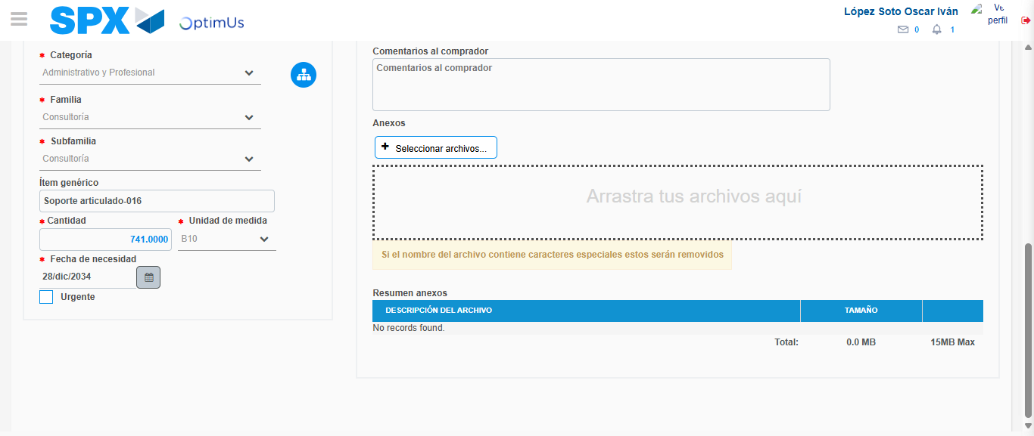Image file-name: QC_Testing-tc005_SPX_Dev5_Crear_Requisicion_Spot_Con_FAD_Tipo_Cobro_Project-1784653714912

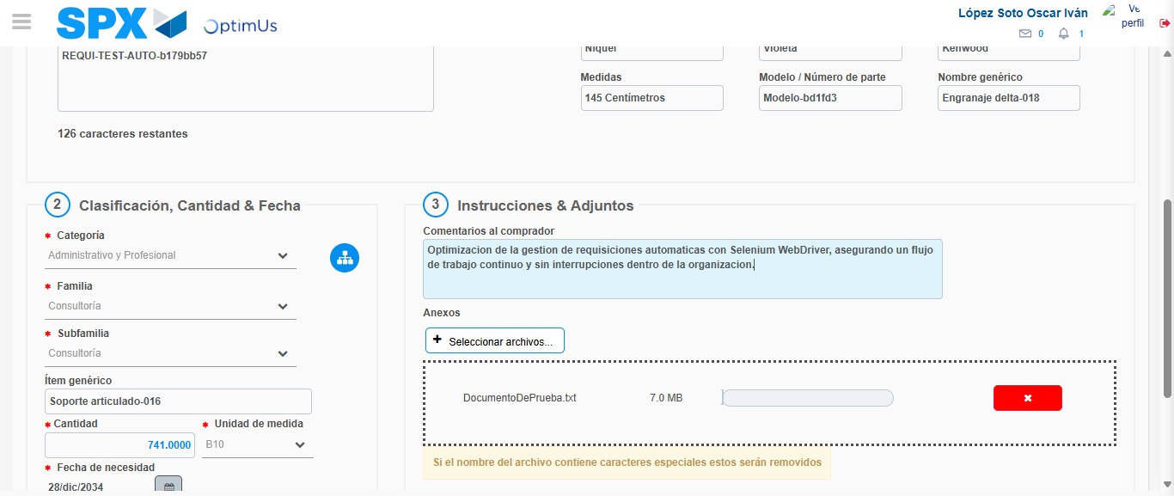Image file-name: QC_Testing-tc005_SPX_Dev5_Crear_Requisicion_Spot_Con_FAD_Tipo_Cobro_Project-1784653715955

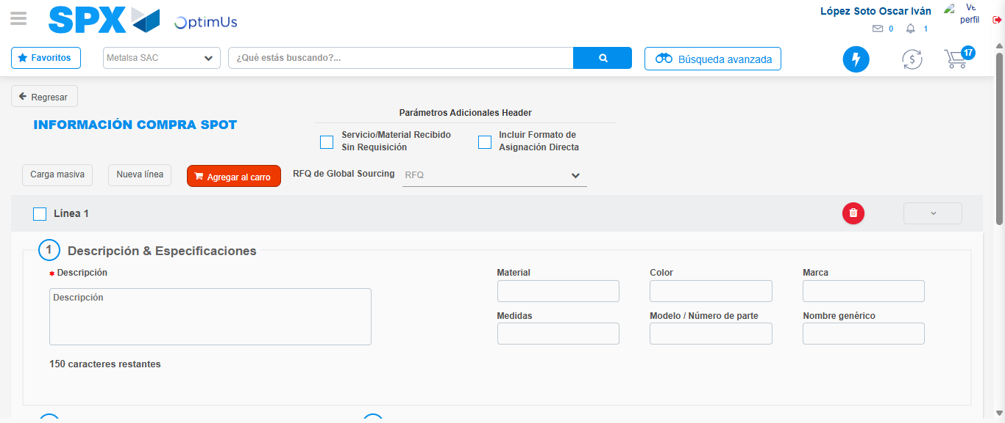Image file-name: QC_Testing-tc005_SPX_Dev5_Crear_Requisicion_Spot_Con_FAD_Tipo_Cobro_Project-1784653723297

Step 8 - Return to Main Page SPX : Return to Main Page SPX
Image file-name: QC_Testing-tc005_SPX_Dev5_Crear_Requisicion_Spot_Con_FAD_Tipo_Cobro_Project-1784653664358

Image file-name: QC_Testing-tc005_SPX_Dev5_Crear_Requisicion_Spot_Con_FAD_Tipo_Cobro_Project-1784653667067

Image file-name: QC_Testing-tc005_SPX_Dev5_Crear_Requisicion_Spot_Con_FAD_Tipo_Cobro_Project-1784653676746

Image file-name: QC_Testing-tc005_SPX_Dev5_Crear_Requisicion_Spot_Con_FAD_Tipo_Cobro_Project-1784653725551

Image file-name: QC_Testing-tc005_SPX_Dev5_Crear_Requisicion_Spot_Con_FAD_Tipo_Cobro_Project-1784653725740

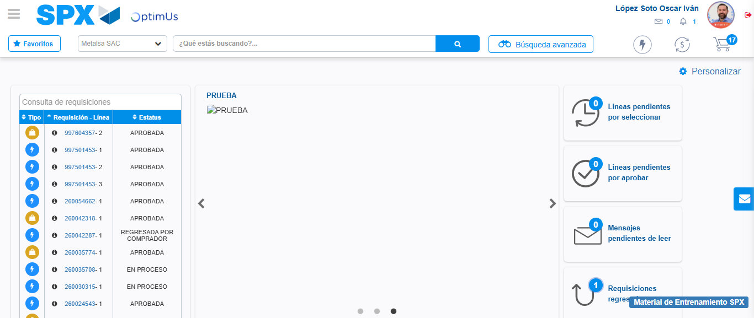Image file-name: QC_Testing-tc005_SPX_Dev5_Crear_Requisicion_Spot_Con_FAD_Tipo_Cobro_Project-1784653747030

Step 9 - Log Out : Log Out SPX
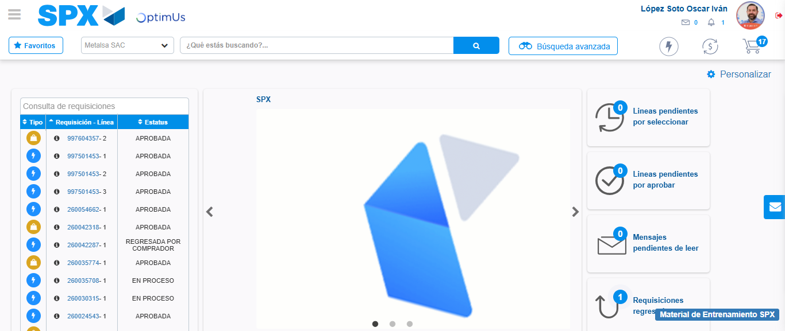Image file-name: QC_Testing-tc005_SPX_Dev5_Crear_Requisicion_Spot_Con_FAD_Tipo_Cobro_Project-1784653747479

